**Output Analysis**

**Steady State Analysis.**

We focus on the steady state analysis of the output from our model. As we decide to analysis the long-term performance of Grab Food platform and how different parameters could affect the model performance.

The main issue for conducting steady state analysis is our model have a long burn in period and need to remove to reduce the initialization bias.

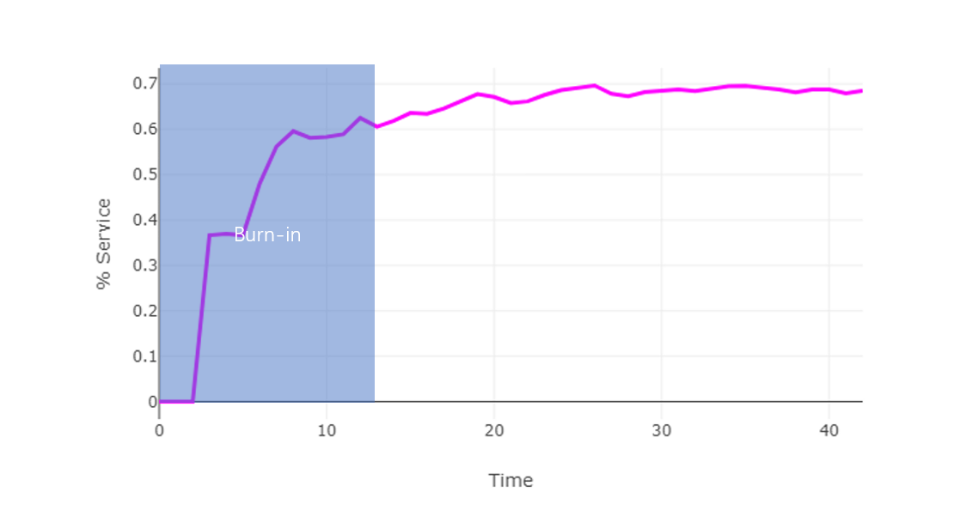

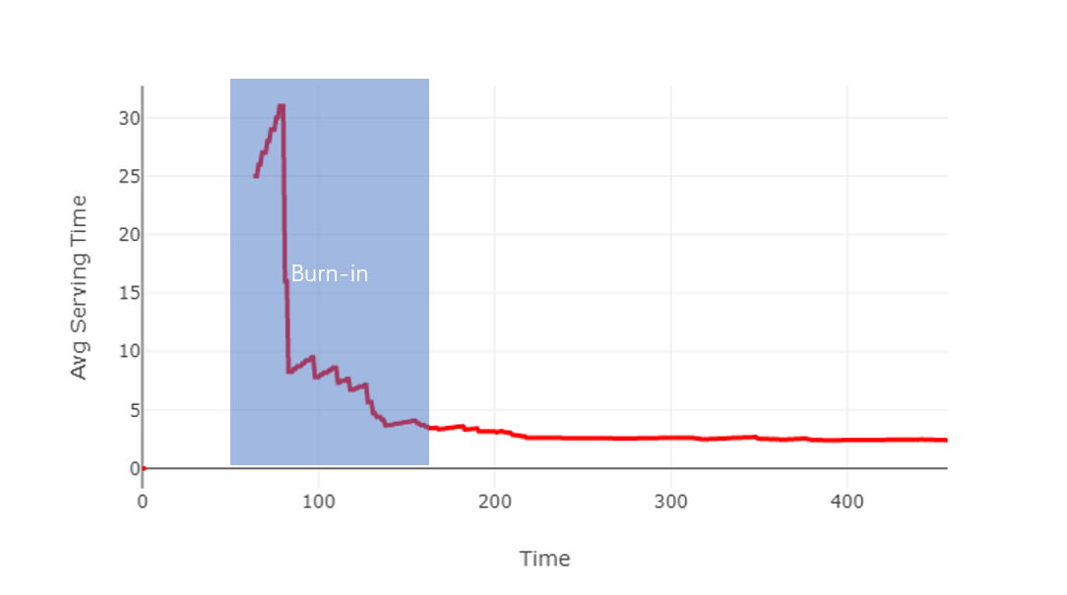

After remove the burn in period, the steady state for our default setting

|  |  |  |  |  |  |  |
| --- | --- | --- | --- | --- | --- | --- |
| probArrival | expoentialrate | number_deliver | number_restaranut | Size | Service Rate | Serving Time |
| 0.7 | 1 | 25 | 20 | 100 | 60% | 2.3 |

**Comparing alternative system configurations**

We decide to use common random numbers (CRN) to get a correct comparison between different configurations. CRN is useful as it could reduce the variance and make more conclusion results.

However, the default random function in JS, after some research, I decide to use the *seedrandom* package.

1. Analysis the effect of changing number of restaurants

The above simulation results are taken from decrease the number of restaurants from max to min step by step. Every step takes similar reduction from the previous number of restaurants. However, the model performance is not linear decrease as the input. When restaurants number is small, decrease give a significant decrease for the whole platform performance.

Suggestion: There might existing a turning point that performance is good with a relatively small number of restaurants.

1. Analysis the effect of changing number of deliverymen

I got a similar observation when comparing number of deliverymen generated. One interesting observation before explosion stage is that average serving time remain almost same when decrease the number of deliverymen, however the proportion of customer served decrease a lot.

1. Analysis the effect of changing restaurant productivity

The above simulation results show that, restaurant productivity is not an important factor for our platform performance. Only very small decrease when I even set the customer arrival rate maximum. This is because time for service an order is highly dependent on the delivery man transportation.

1. Analysis the effect of changing the size of region

Both performances gained improvement when segmented the whole city and use smaller region size but not significant.

Conclusion

From the output analysis shown above, we found out some factors we thought will affect our model performance initially do not significant influence our model performance. We also observe some interesting and unexpected outcomes, which indicates there are more analysis can be done to our model. For example, run priori optimization model such as weighted goal programming to find the optimal solution on the number of restaurants and delivery men.